**International Academy of Arts & Sciences Summer Program**

Experience both American and Japanese culture through numerous fun activities! We also provide swimming classes with professional coaches at a local swimming pool.

Dates：6/22/2015 (Mon) - 8/14/2015 (Fri)　(4 terms/8 weeks in total)

　　　 *No school on July 3rd, due to Independence Day.

You can register daily.

Please write down the days you want to enroll for.

Time：9:00am - 2:30pm

Place：International Academy of Arts and Sciences

300 High Street, Closter, NJ 07624

Ages：2.5 - 7 years old

Course：☆ English - Japanese Bilingual Pre-school course

1st term　Let's learn about America & Tanabata Festival

2nd term　Under the Sea

3rd term Matsuri - Japanese Festival

4th term IAAS Circus

☆Swimming lessons (2nd - 8th week)

*Swimming lessons at Pascack Valley Swim Club!*

(http://swimpascack.com/)

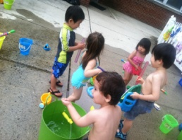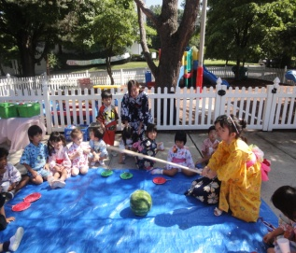

Capacity：60 children

Registration Fee：$50

*No Registration fee for the students already enrolled in

IAAS for 2014 - 15 school year

Tuition：Registration by week

1st Week: $342 (No swimming class this week)

2nd Week: $294 (Swimming on Tue & Thu, No school on Fri)

3rd - 8th Week: $384/week (Swimming on Tue & Thu)

Registration by day

No Swimming class day: $74 per day

(1st week and Mon, Wed, Fri for 2nd - 8th week)

Swimming class day: $95 per day

(Tue & Thu for 2nd - 8th week)

*You need to register and pay in advance for daily registration, too.

*We cannot make up days or give a refund if your child is absent.

　　 *We also have some discount options.

　　　(Please check with your application form.)

We will have a van service for some areas. ($10/ride)

How To Enroll：

Please return the registration form and a check to us.

Make sure that the form is all filled out properly.

We will send you all the additional documents.

**International Academy of Arts and Sciences**

Tel：201(767)1144

Email：info@asunarokokusai.org

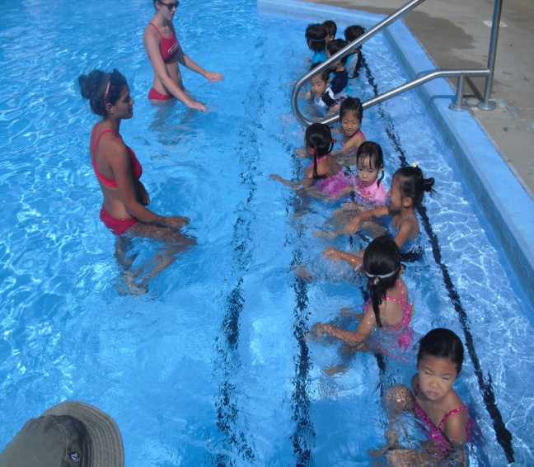

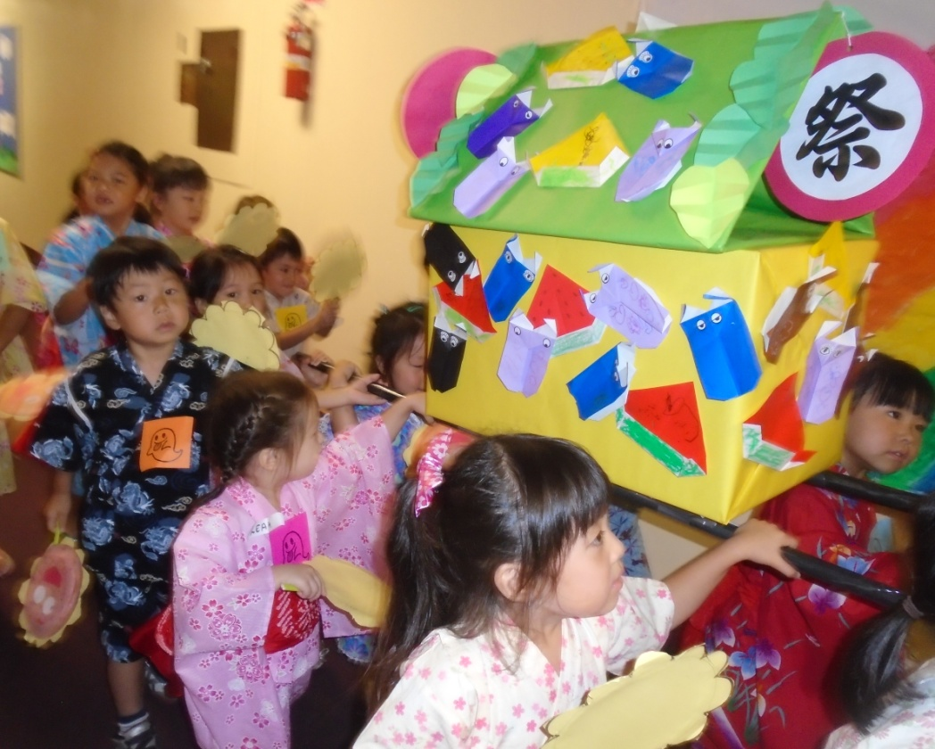

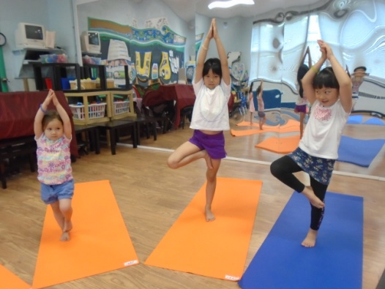

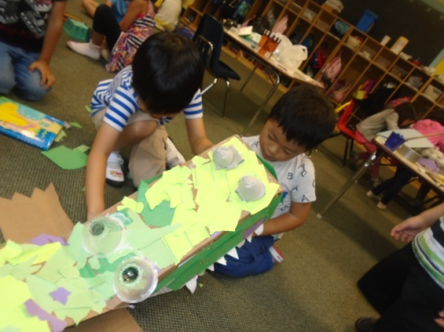

**Register Now!!**

**International Academy of Arts and Sciences**

300 High St, Closter, NJ 07624

Phone：201(767)1144

Email:info@asunarokokusai.org

Blog: http://asunarokokusai.blogspot.com

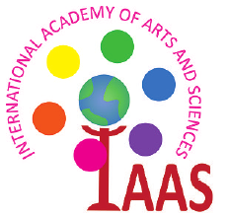 **2015**

**Summer School**

**International Academy of Arts and Sciences**